ULINK REPORTING SYSTEM – DASHBOARD

February 2017

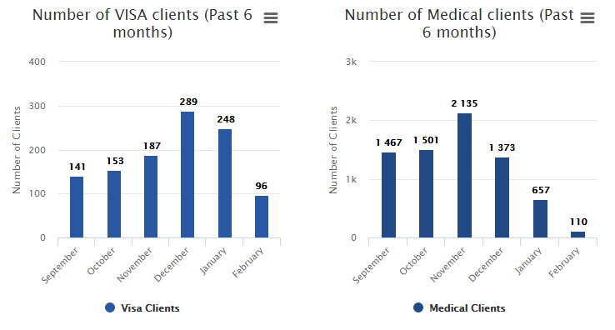

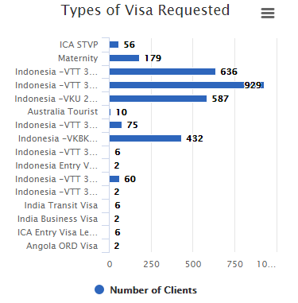

**TOP 5 DOCTORS**

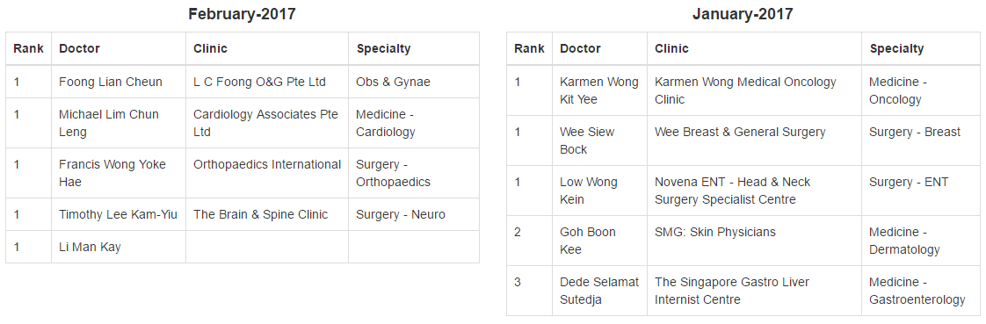

**TOP 5 REFERRAL SOURCES**

